BRIAN’S
REMOVALS
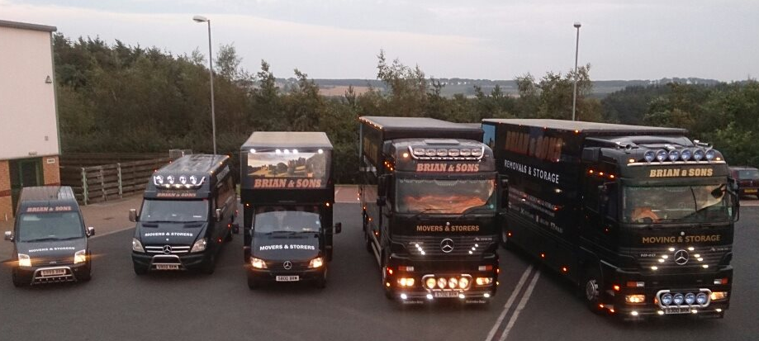
Home Removal Pack
- Fully Insured
- Movers, Packers and Shippers
- Fully Alarmed Premises
- Containerised Storage

Contact Details:
Brian & Son’s Removals and Storage
Unit 14 Oak Drive
Lionheart Enterprise Business Park
Alnwick
Northumberland
NE66 2EU
Telephone: 01665 605634
Email Address: brian.removals@aim.com
Website: www.removalsandstoragealnwick.co.uk

Welcome

Firstly on behalf of our company we would like to welcome you to Brian & Sons Removals.
Brian and Sons Removals were established by Mr Brian Egdell in 1970 at a young age of 27. Brian started with one truck and began by offering removals locally. It became clear to Brian that there was a gap in the market and he began branching out further afield. Brian increased his fleet when his two sons Sheldon and Nathan were old enough to drive. A few years working alongside his father, Sheldon felt the business would benefit from offering a storage service. Brian agreed with his son and welcomed his enthusiasm. The business that offers U.K, European and International removals as well as containerised secure storage is now a name that people are familiar with all over the country.
Sadly Brian passed away in November 2014 but his legacy and business will live on in the hands of his son Sheldon.
YOU CAN RELY ON US
- DOMESTIC REMOVALS
- LOCAL and LONG DISTANCE
- COMMERCIAL REMOVALS
- PIANO REMOVALS
- FINE ART and ANTIQUE REMOVALS
- REGUALR TRIPS TO LONDON
- PACKING SERVICE
- STORAGE SERVICE
- FULLY INSURED
- FRIENDLY and PROFESSIONAL SERVICE
- CLEANING SERVICE ALSO AVAILABLE

Gan canny till ya back in Northumberland

FOR A PLEASANT AND CARE FREE MOVE

Moving home can be very stressful and that is why we have compiled this booklet to guide you through the process and hopefully reduce any of the worries or concerns you may be experiencing.

Move consultation

General good practice is for one of our team to visit you in your home to assess your move. This time also gives us the opportunity to understand your requirements and to ensure we have all the information required to make your move as comfortable as we can.

This consultation should not take more than an hour; it depends entirely on the size of your property.

What we need to see / know
- All rooms that will be moved - please allow us to look inside storage cupboards if possible as this will allow us to determine the type and amount of boxes required and the time it will take the team if you have selected our packing service.
- The loft - places like the loft can be easily forgot. Please make sure you inform us of anything that will require moved.
- The garden – plants and garden items can be hard to stack/load tightly in a moving truck so we need to make sure we have enough space available to move these safely.
- Sheds/Garage/Outbuildings/Basement – please make sure you inform us of any items that will need to be moved.
DON’T FORGET to tell us if you are buying / obtaining any other items prior to your moving day as well as any items you won’t be taking.

- Remember – items that may need extra packaging

Other Services

As well as answering your questions and finding out what is included in your move we will also want to know what you require from us. This will ensure we can give you a tailor made service.

We offer a range of packing services from full packing and part packing service, or if you prefer to do the packing yourself we will supply you with the packing materials.

Please also think about:
- Dismantling and re-assembling items
- Disconnecting and reconnecting electrical items

Please ask what we are able to offer you.

Deep cleaning service is also available; please ask during your consultation

Key waiting time

Are you completing a house sale on the day of your move? Do you know what time keys will be available?

Any delays gaining access may mean the move takes longer than planned. Please note that waiting for keys may incur an extra charge to you.

Dates Do you know when you want to move?

We can provisionally book a date for you and can agree an exact date nearer the time. PLEASE NOTE A CHARGE MAY OCCUR IF PROVISSIONAL DATES ARE NOT COMPLETED WITHIN AN APPROPRIATE TIME SCALE

It is worth noting that School and seasonal holiday periods are busy times for us, the demand is higher as customers have more time for the move or can allow their children to join a new school at the start of a term. If you need to move during a peak period we would advise you try and confirm your move date as early as possible to ensure we are available.
It is also worth noting that should you require a move at a weekend the cost of your move will be slightly higher.

Storage

If you’re moving out does not correspond with your moving in date our storage solutions may be your answer. Please ask during your consultation should you require this part of our service.

Accessibility

Although we assess the layout of your home as to how we will get your belongings out of your current house it isn’t easy to evaluate for your new house and therefore we will rely on what you can tell us.

Things to remember are:
- How close can we park our vehicle – are there any tight lanes? Low bridges on route to your new property? Is there a long pathway?
- If you are moving into an apartment building – how far is the internal walk from the main entrance to your apartment?
- Ground floor or upstairs apartment – this is important for us to know as the cost will depend on this
- Any obstacles – internal or external that might be difficult for us such as low doors, ceilings, narrow hallways, spiral staircases.

The cost is calculated from:
- Your volume of goods
- Special care items
- Access and transportation
- Packing / unpacking requirements
- Any additional services you may have requested

What next?

If you do decide to use our service/s please note that on completion you will be given a feedback form from your removal team. Could you please oblige by setting some time aside to complete this and returning it to Checkatrade.com

There’s a lot to remember when it comes to moving house, from all the big physical stuff right down to the small bits of paperwork so it’s no wonder that there are some things that get left behind and/or some things you may forget to do. Our handy checklist may help you track your progress of collecting, informing and completing.
DO NOT FORGET
- Items from dry cleaners, tailors or shoe repairs
- All personal records must be kept in a safe place
- Keep regular medication on your person
- Any Library books to return
- Any spare keys that are held by neighbours/ family / friends

Service | Date Contacted | Notes

Banks/ Building Societies

Broadband

Car breakdown

Charities

Council

Credit Cards

Dentist

Doctor

DVLA

Energy - Electricity

Energy - Gas

Health Clubs / Gym

Insurance - Car

Insurance - Health

Insurance - Home

Insurance - Travel

Magazine / Newspaper subscriptions

Mail order / Internet shopping

Memberships
Service | Date Contacted | Notes

Mortgage

National Blood Service

Passport

Pensions

Post Office / redirect mail

Rental / Hire Purchase Agreements

Savings

Schools / Playgroups

Shares / Investments

Store Cards

Telephone (landline)

Telephone (mobile)

TV (digital / cable provider)

TV (licensing)

Veterinary practice

Water

Workplace

Labelling boxes properly is actually one of the top things people forget when moving house - yet one of the most important! Always label your boxes in marker pen with the name of the room they are to be put in when unloading. Mark any box containing fragile items clearly as this will ensure the crew take extra care when loading and unloading it from the truck, and mark anything that’s got priority items in it with a number so that it gets unpacked first.

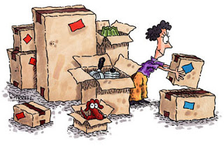
PACKING AN ESSENTIALS BOX
This is something that a lot of people often overlook; believing that once they reach their new house it will be easy to access everything they need at once. Well actually, it won’t. Depending on the time of day you move, you might not have the time or the energy to start unpacking properly when you get to your new house, and the last thing you need is to be rooting through all of your boxes in search of your essentials before bed.

Make a list of what you need and start packing your essentials box in plenty of time, preferably just before everything else as this gives you the chance to check against your list and add things that might have been forgotten on the first pack. Then first thing on the moving day is to either put it in the car so that it’s out of the way and completely separate from the rest of your boxes or clearly mark it “ESSENTIALS” to avoid any mix ups when loading and unloading the truck.
Our table below may help start you off.
ITEM |  | ITEM
KETTLE |  | TEA/COFFEE
MILK / SUGAR |  | SOFT DRINKS
SNACKS |  | BASIC CUTLERY / CROCKERY
SCISSORS |  | BOTTLE/TIN OPENER
TOILETRIES |  | TOILET PAPER
HAND TOWELS |  | BEDDING
FIRST AID KIT |  | MEDICATION
LIGHT BULBS |  | BASIC TOOLS/ TORCH
PET ITEMS |  | SCHOOL UNIFROMS
MONEY / CREDIT CARDS |  | PHONE CHARGERS
KEYS |  | NOTE PAD / PEN
DON’T FORGET…..Before you leave your old home do a proper walkthrough once you think everything’s out, open all cupboards and drawers and don’t forget the loft and outside spaces – don’t just quickly glance in the rooms!
Houses, Castles, big or small we at Brian’s move them all

